Method of Procedure Upgrade Agent OEM on ZDLRA

 | 

PT. TELEKOMUNIKASI SELULAR
AND
PT. SIGMA SOLUSI INTEGRASI



Document History
Document Title | Version | Created By | Date
Method of Procedure Upgrade agent OEM on ZDLRS | 1.0 | Dede Sulaiman | 30 Sept 2020

Revision History
Date | Name | Version | Summary of Changes
30 Sept 2020 | Dede Sulaiman | 1.0 | - Initial document.

Approvals
Name | Department | Date | Signature
Perdana Rizki Hanafi | Manager Database Administration Management
Taufik S Hidayat | Officer – IT Database Administration Management

Detail Implementation Plan Restore database
This is Detail Implementation explains the activities of upgrade agent oem on zdra tbs and zdlra bsd

Activity Description
Upgrade agent oem.

- Activity Schedule
Activity, detailed schedule at below:
N | Activities | Estimated Time (minutes) | Start Date/Time | End Date/Time | PIC | DownTime (Yes/No)
Implementation Plan Date
1 | Pre-check | 20 | 30 Sept 2020 22:00 | 30 Sept 2020 22:20 | DBA | No
2 | Move segment | 180 | 30 Sept 2020 22:20 | 30 Sept 2020 01:20 | DBA | No
3 | Cross-check & monitoring | 20 | 1 Oct 2020 01:20 | 01 Oct 2020 01:40 | DBA | No

Total Activities Time: 210 Minutes

- Person in Charge

Below is the person in charge :
2. 1 Telkomsel
NO | Name | Phone | Email
1 | Perdana Rizki Hanafi | +62 811-897-054 | perdana_r_hanafi@telkomsel.co.id
2 | Taufik S Hidayat | +62 811-370-083 | taufik_s_hidayat@telkomsel.co.id
3 | Wahyu Setiawan | +62 811-8035-427 | wahyu_setiawan@telkomsel.co.id
4 | I Nyoman Wahyu | +62 811-8383-798 | i_npw_dharmawan@telkomsel.co.id

2. 2 Vendors
NO | Name | Role | Contact | Shift
1 | Deddy Sitanggang | L2 DBA | ssi_dba_core@sigma.co.id | S3
2 | Abdul Hafizdh Kamal | L1 DBA | ssi_dba_core@sigma.co.id | OFF
3 | Agung Purwanto | L1 DBA | ssi_dba_core@sigma.co.id | S2
4 | Lamberg Nicholas | L1 DBA | ssi_dba_core@sigma.co.id | OFF
5 | Fachur Rochman | L1 DBA | ssi_dba_core@sigma.co.id | S1
6 | Slamet Riyadi | L2 DBA | ssi_dba_core@sigma.co.id | OH
7 | Dede Sulaiman | L2 DBA | ssi_dba_core@sigma.co.id | OH
8 | Yose P | PM MODB | ssi_dba_core@sigma.co.id | OH
S1 : 06:00 AM – 14:00 PM
S2 : 14:00 PM – 22:00 PM
S3 : 22:00 PM – 06:00 AM
OH : Office Hour
SCRIPT MOVE SEGMENTS
1. choose setup-> managed cloud control-> upgrade agent
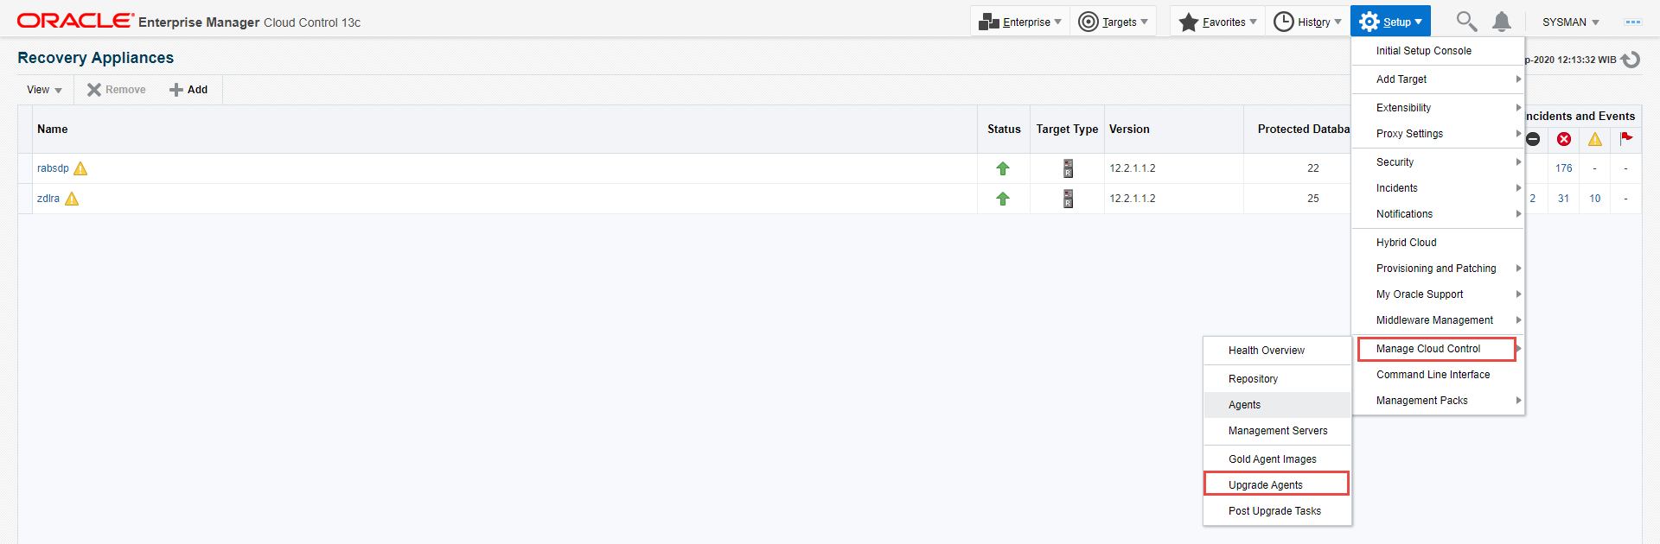

2. choose agent want to upgrade
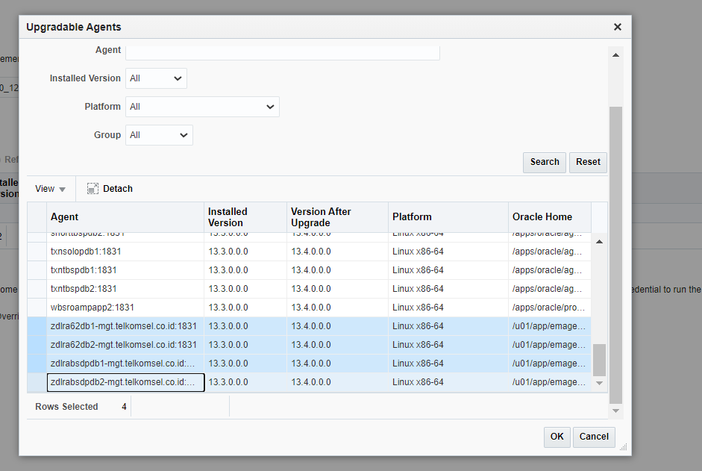

3. click submit
